Totaal Software

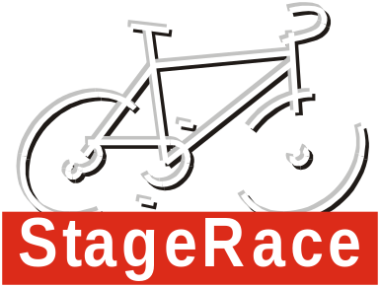

Style Guide
Subjected version: 2002.2.00
Date: February 2002

Dialog resources 2
Controls 2

This document briefly describes the style regulations used for the StageRace software product.

Dialog resources

Dialog margins

Category | Item | Value
Inside margins | Top/Bottom | 20px
 | Left/Right | 20px

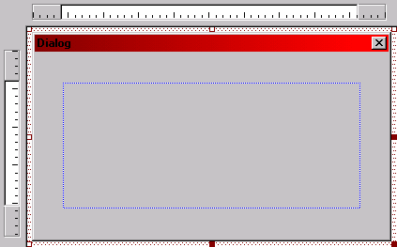

Controls

Buttons

Category | Item | Value
Basic dimensions | Height | 23px
 | Width | 50px
Distances | Between buttons | 7px

Edit boxes

Category | Item | Value
Styles | Border | No
Extended styles | Static edge | Yes
Accompanying static texts | Text alignment | Left
 | Horizontal alignment | Top aligned with edit box’s top
 | Text content | No ending colon
Dimensions | Minimum height | 14px
 | Advised height | 14px

Group boxes

Category | Item | Value
Styles | Flat | Yes
Usage | Only to be used for separating groups of controls; single group boxes on a dialog or view are not to be used
Distances | Between group boxes | 10px
Inside margins | Top | 20px
 | Bottom | 10px
 | Left/Right | 15px

Spin

Extended styles | Static edge | Yes

